**Patent Application File**

By: **Cindra Zakaria**. February 10, 2021 15:01:16

Patent Application File

1. Guidelines for Paper Size Limits and Writing Procedures for Creating Patent Specifications
2. Abstract Sample
3. Claim Sample
4. Description Sample
5. Patent Image Template sample (if any)
6. Declaration of Ownership of Invention
7. Letter of Transfer of Rights to Invention (to UNG)
8. 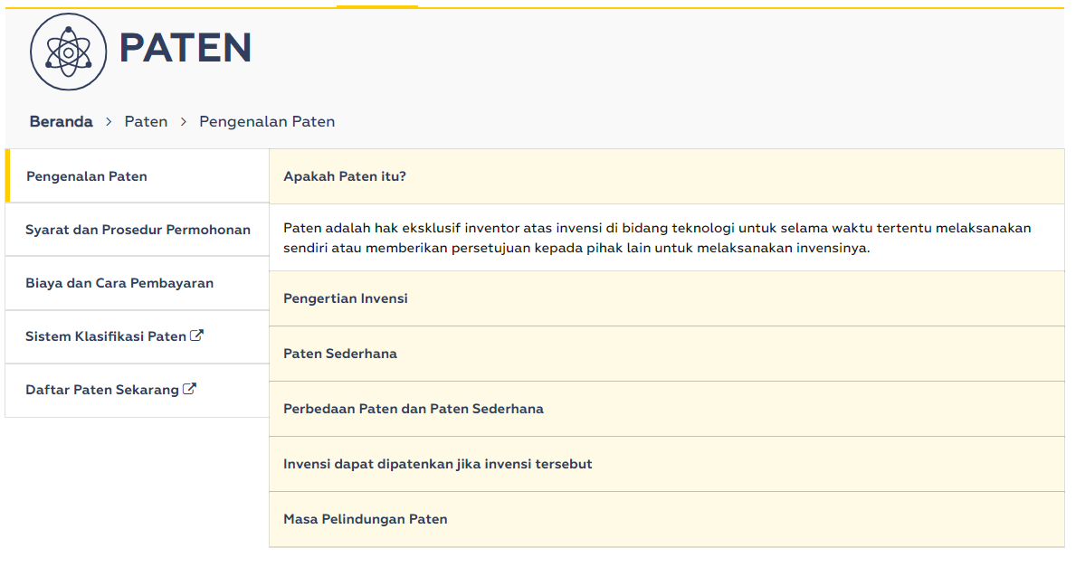Others (Fees and Procedures)

*Beranda*: Home

*Paten*: Patent

*Pengenalan Patent*: About Patent

*Syarat dan prosedur permohonan*: application terms and procedures

*biaya dan cara pembayaran*: fee and payment method

*sistem klasifikasi paten*: patent classification system

*daftar paten sekarang*: register now

*apakah paten itu*: what is patent?

*paten adalah hak eksklusif inventor atas invensi di bidang teknologi untuk selama waktu tertentu melaksanakan sendiri atau memberikan persetujuan kepada pihak lain untuk melaksanakan invensinya*: Patent is the exclusive right of the inventor to the invention in the field of technology for a certain period of time to carry out himself or give approval to other parties to carry out his invention.

*pengertian invensi*: definition of invention

*paten sederhana*: simple patent

*perbedaan paten dan paten sederhana*: patent vs simple patent

*invensi dapat dipatenkan jika invensi tersebut*: an invention can be patented if

*masa perlindungan paten*: patent protection period